**Question 1**

1. Write a program to read a set of numbers (between 10 to 20) from the keyboard and store them in an array.
2. Sort the numbers in ascending order with the Insertion sorting algorithm.
3. Calculate how many times it executes the while of the algorithm.

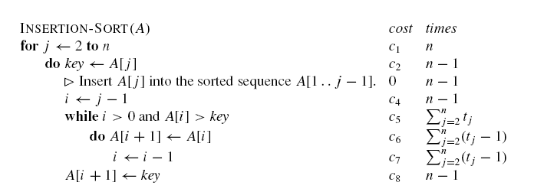

**Question 2**

Bubble Sort is a popular sorting algorithm. It works by repeatedly swapping adjacent elements that are out of order.

BUBBLESORT(A)

1. **for** i = 1 **to** A.*length* – 1
2. **for** j = A.*length* **downto** i + 1
3. **if** A[j] < A[j – 1]
4. exchange A[j] with A[j – 1]
5. Read 8 numbers from the keyboard and store them in an array. Sort the numbers using the bubble sort algorithm.
6. Find out the time complexity of bubble sort in Big O Notation.